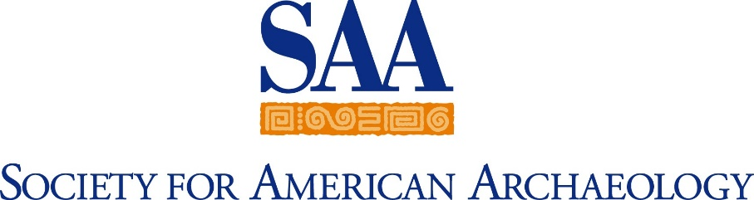
Matthew Tobin Cappetta Scholarship
Proposed Budget (worth a possible 10 points): See instructions at end of document.
NOTE: Scholarships do not cover conference fees/attendance, professional membership fees, or publication subscriptions. Maximum Award amount for 2024 is $2,500.
1. Tuition and fees | $
2. Airfare/travel costs | $
3. Transportation at location | $
4. Lodging | $
5. Meals | $
6. Equipment (itemize below) | $
7. Supplies, textbooks; itemize below (under $500) | $
8. Other (please describe below) | $
9. Other (please describe below) | $
TOTAL | $
Space provided below for supporting narrative, if needed:

