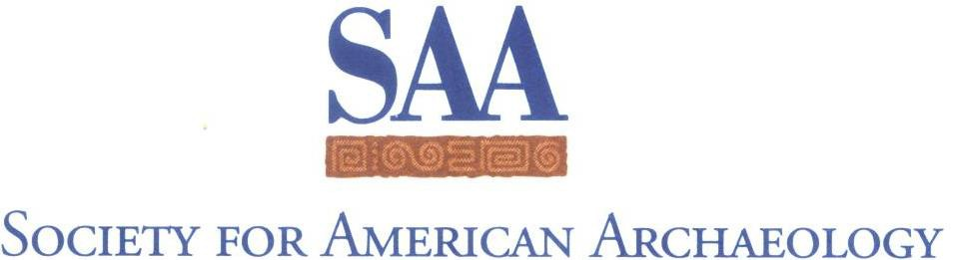

**Committee/Task Force Chair Report to the Board of Directors**

March 2025

**Please cc: all committee and task force members are carbon copied on the transmittal email.** If committee members have comments on the report to the Board, please contact the Committee/Task Force board liaison within 3 days.

The Board requests all committee and task force chairs use this word document to report to the Board. Reports are required for the Board meeting held at the Annual Meeting each year, but reports are optional for the September/October Board meeting.

|  |  |
| --- | --- |
| Report of the | Native American Scholarship Committee |
| From Chair | Davina R. Two Bears |

1. **Membership and terms for your committee:**

*So that the SAA Office’s records are as complete as possible, please list your committee members and their terms here. Please also note if there are anticipated changes in a member’s status before their term end date.*

Note: all committee members must review the report prior to submission

|  |
| --- |
| Travis K. Armstrong, term ends 5/1/2026  Beau D. Carroll (Co-Chair and next Chair), term ends 4/25/2025  Aaron Comstock, term end 4/9/2027  Jerald Ek Romero, term ends 4/9/2027  Katharine W. Fernstrom, term ends 4/9/2027  Ervan G. Garrison, term ends 4/19/2025  Ian Kretzler, term ends 4/25/2025  Natalia Miles, term ends 4/9/2027  Desiree R. Martinez (Board Liason)  Chuck R. Riggs, term ends 4/25/2025  Charlotte Sunseri, term ends 4/9/2027  Davina Two Bears (Chair), term ends 5/1/2026  Elizabeth Watts Malouchos, term ends 5/1/2026 |

1. **Executive summary of Committee’s/Task Force’s activities over the past year:**

*Please note that the activities summary should not exceed 250 words. Should the committee or task force be responding to a Board request for a draft document or report, refer to it in the summary and forward it with this form as an attachment. If no such document was requested by the Board, the executive summary should be confined to the word limit.*

Note: no report should include ad hominem or denigrating comments about another party or individual. These reports are shared publicly to facilitate transparency among the organization, (such as helping future chairs understand the main policy concerns of the Committee or Task Force.)

|  |
| --- |
| 1. Davina Two Bears and Carla Hernandez Garavito organized a session for the 2025 SAA annual meeting in Denver, entitled “Forum Creating Opportunities: A Conversation on the Impacts, Needs, and Future Directions of the SAA Native American Scholarships and the Student Excellence in Archaeology Award.” It will take place on Sunday morning from 8am-10am. We invited past recipients of the Native American Scholarship and Student Excellence in Archaeology Scholarship as part of this forum to discuss how they used their scholarship and to have a conversation about continued support and growth of both scholarship programs. 2. Davina Two Bears attended the Pecos conference last August 2024, and handed out the SAA’s Native American scholarship fliers to Indigenous archaeologists in attendance. 3. In the fall of 2024 a QR Code was added to the flier advertising the SAA Native American Scholarships. 4. In 2024 the SAA Native American scholarship was advertised on the [American Indian College Fund’s](https://collegefund.org/students/scholarships/additional-scholarships/) website. 5. On November 15, 2024, the Native American Scholarship Committee (NASC) members voted Beau Carroll as the Co-Chair of the NASC and the future Chair (after I cycle off on 5/1/2026). 6. Beau is creating a new banner to advertise the SAA Native American Scholarships at the silent auction booth for the 2025 SAA annual meeting. |

1. **Items for Board Consideration, if applicable. These are recommendations and requests that specifically require Board approval.**

*These items range from statements that you may wish to be disseminated, requests to undertake projects, requests to disseminate results, or any other action for which a committee or task force needs specific Board guidance/approval. Please do not embed such items in your activities summary. These items must be separately listed in this section. These are actions you are asking the Board of Directors to take. Please also include a discussion of fiscal impacts, if any.*

*Should you have questions about whether any of your Committee’s items require Board approval, please consult with your Board Liaison prior to submitting your report. We also recommend that you run a draft of your report by your liaison before you “officially” submit it.*

Note: no report should include ad hominem or denigrating comments about another party or individual. These reports are shared publicly to facilitate transparency among the organization, (such as helping future chairs understand the main policy concerns of the Committee or Task Force.)

|  |
| --- |
| 1. Requesting that the Society for American Archaeology ask for a renewal of funding from the Autry Museum of the American West for the Bertha Parker Cody Scholarship.  2. Waiving the SAA membership fee and registration fee for Native Americans, Alaskan Natives, and Native Hawaiians in perpetuity. |

1. **Draft motions, if appropriate. (Optional)**

*Drafting a suggested motion or motions for any requests noted above will help the Board more clearly understand your request and increase the “fit” between the request you make and corresponding Board action. Please keep in mind that suggested motions may be revised or not accepted by the Board, whose responsibility it is to consider the full range of member needs. If you choose to include suggested motion(s) with your report, consider working with your liaison before you submit.*

|  |
| --- |
| The Native American Scholarship Committee motions that all Native Americans, Alaskan Natives, and Native Hawaiians have the cost of their SAA membership and registration fees waived in perpetuity. |