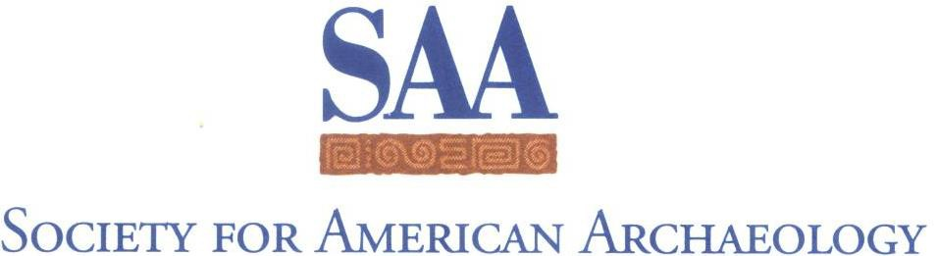

Committee/Task Force Chair
Spring 2022 report to the Board of Directors

Due to CAS Chair and Board Liaison on February 1, 2022, for inclusion in the materials for the Spring Board of Directors Meeting. Your report serves to inform the SAA Board of the committee/task force’s accomplishments and as background for the action items.
The Board asks all committee and task force chairs to use this Word document to report to your Board Liaison (paola.schiappacasse@upr.edu).
- Reports are required in the spring of each year and optional in the fall.
- Starting in 2022, Executive Director will post reports on Committee pages to improve transparency and assist incoming future chairs.
- If you are able to join us in Chicago, Committee and Task Force chairs are invited to join the Board for breakfast on Saturday April 2. I will send an invitation in the first week of February to the breakfast.

Report of the | Committee of the Award for Excellence in Latin American and Caribbean Archaeology
From Chair | Shawn Morton
Date | February 1, 2022

- Membership and terms for your committee:
So that the SAA Office’s records are as complete as possible, please list your committee members and their terms here. Please also note if there are anticipated changes in a member’s status before their term end date.
Charlotte Goudge – 2023-03-31
Veronica Perez Rodriguez – 2023-03-31
Meaghan M. Peuramaki-Brown – 2022-04-01
Jordi A. Rivera Prince – 2022-04-01
Rafael Vega-Centeno – 2023-03-31

- Executive summary of Committee’s/Task Force’s activities over the past year:
Please note that the activities summary should not exceed 250 words. Should the committee or task force be responding to a Board request for a draft document or report, refer to it in the summary and forwarded with this form as an attachment. If no such document was requested by the Board, the executive summary should be confined to the word limit.

This year, the committee completed its charge of selecting a recipient for the Award for Excellence in Latin American and Caribbean Archaeology. The committee decided that Dr. Awe should be this year’s award recipient.

- Items for Board Consideration, if applicable. These are recommendations and requests that specifically require Board approval.
These items range from statements that you may wish to be disseminated, requests to undertake projects, requests to disseminate results, or any other action for which a committee or task force needs specific Board guidance/approval. Please do not embed such items in your activities summary. These items must be separately listed in this section. These are actions you are asking the Board of Directors to take. Please also include a discussion of fiscal impacts, if any, but note that budget requests occur in advance of the Fall Board meeting (and not as part of this report).
Should you have questions about whether any of your Committee’s items require Board approval, please consult with your Board Liaison prior to submitting your report. We also recommend that you run a draft of your report by your liaison before you “officially” submit it.
As per usual, this cycle, the committee was tasked with reaching out through their various networks and contacts to encourage the submission of nominations. As was the case last cycle, several committee members (myself, included) reported receiving responses that indicated a hesitation to engage in a process perceived of as time consuming (perhaps a COVID-related reaction?). In the end, we received only two nominations (detailed below), both of which were updated resubmissions from the previous year’s competition.
While both nominees represent a senior and unquestionably worthy candidate, there are some clear biases in representation with the award that were formally noted last year. These biases extend over several years; I first joined the committee in 2017 and it was noted then:
First, nominations are overwhelmingly of men (though two of our previous three awardees were women).
Second, nominations and awardees tend to be biased toward individuals either not hailing from Latin America or the Caribbean, and/or not working at institutions in Latin America or the Caribbean (i.e. it is dominated by “outsiders”, predominantly employed at larger/prestigious American institutions).
Third, while in my time on the committee I have only been involved in the evaluation process four times, as far as I can recall, we have never had a nomination whose primary work was in either Amazonia or the Caribbean. Committee members again made explicit attempts to reach out to these communities this round to no avail. Several colleagues working in the Caribbean noted that this may be related to the fact that the SAA does not necessarily represent the preferred organization for scholars and professionals working in that region. Perhaps the same is also true of Amazonia?
Finally, there is a distinct age bias to both nominees and awardees that may play into the lack of diversity noted above. While the award description—honoring someone who has made significant and lasting contributions to Latin American and Caribbean archaeology—may skew in favor of those with longer careers behind them and with the resources and reach of larger American institutions, there is no explicit reason that a relatively early career scholar or a scholar at a smaller institution could not be recognized. Indeed, the award guidelines state that nominations are to be evaluated in relative terms. Explicitly emphasizing that this IS NOT a lifetime achievement award in the award guidelines/description might alleviate some of these issues as well.

- Draft motions, if appropriate. (Optional)
Drafting a suggested motion or motions for any requests noted above will help the Board more clearly understand your request and increase the “fit” between the request you make and corresponding Board action. Please keep in mind that suggested motions may be revised or not accepted by the Board, whose responsibility it is to consider the full range of member needs. If you choose to include suggested motion(s) with your report, it is essential that you work with your liaison before you submit your report. They will be able to provide examples of motions that you can use as models for the ones you create.

- For Award and Scholarship Committee Chairs: Number of Applicants/Nominees and Gender Identities of Applicants/Nominees and Awardee.
The Board has requested that Award and Scholarship Chairs report annually on the total number of applicants/nominees received for each award/scholarship, the number of applicants/nominees broken down by gender identity, as reflected by pronouns used in application/nomination packet (he, she, they), and the gender identity of the awardee(s).

Our two nominees were:
Dr. Jaime Awe (male/he)
Dr. Richard Burger (male/he)

